**Package Organization**

1. Package organization model: MVC model

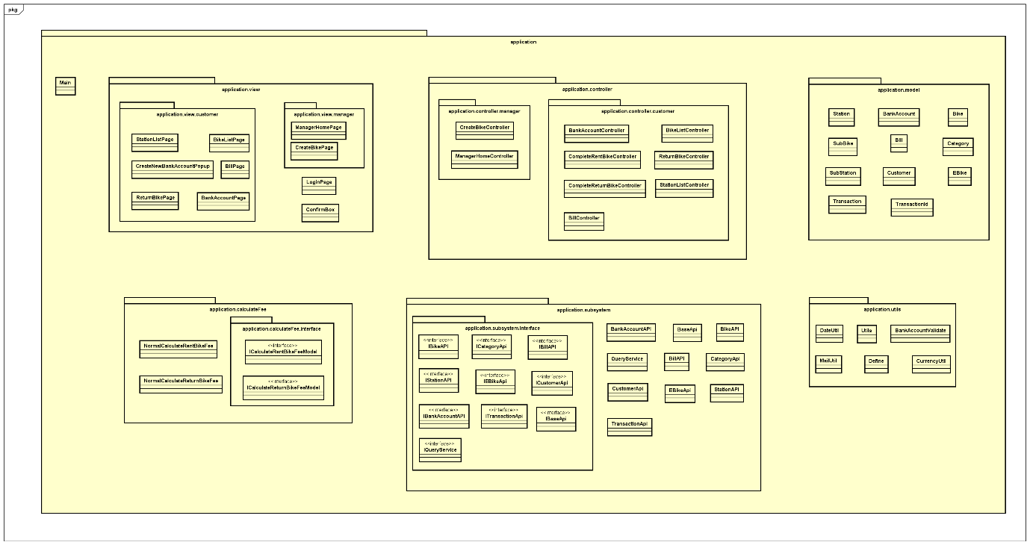

1. Package meaning explanation:

- application: contain the entire the program

- application.model: contains all the objects in the program such as bike, station and customer

- application.view: contains the user interfaces (theme). Divided into 2 sub-packages application.view.customer and application.view.manager are for customers and managers.

- application.controller: responsible for handling user requests made through the view. From there, the controller gives the right data to the user. Besides, the Controller also has the function of connecting to the model

- application.utils: contains utilities such as sending email, validating bank account, normalizing dates and currencies, etc.

- application.calculateFee: contains classes used to charge when starting to rent a car, charging when returning the car. It can be easily upgraded and maintained or modified charging manner.

- application.subSystem: Contains APIs that help the model connect to the database for manipulation such as viewing, retrieving, processing data, etc.

1. Communication and navigation screen methods

- Navigating to the next screen: pushViewController(ViewController vc), where the function changeScreen(ViewController vc) is used to change the screen.

- Back to previous screen: popViewController()

- Back to the previous n screens: popViewControllers(int n)

- Back to the root screen: popToRootViewController()